Review / Revision Record
REVISION | DESCRIPTION | APPROVED | DATE
A | Initial Release | Alejandra Reyes | 01-23-2026

This document is for internal use only and may not be reproduced in any form or by any means, including electronic, without the prior written consent of Standard Meter Lab.

When printed this document becomes uncontrolled.



EMERGENCY ACTION PLAN

IN CASE OF EMERGENCY CALL 9-11

Our Address: 236 Rickenbacker Circle Livermore, CA 94551.

Emergency Meeting Location: 222 Rickenbacker Cir, Livermore, CA 94551
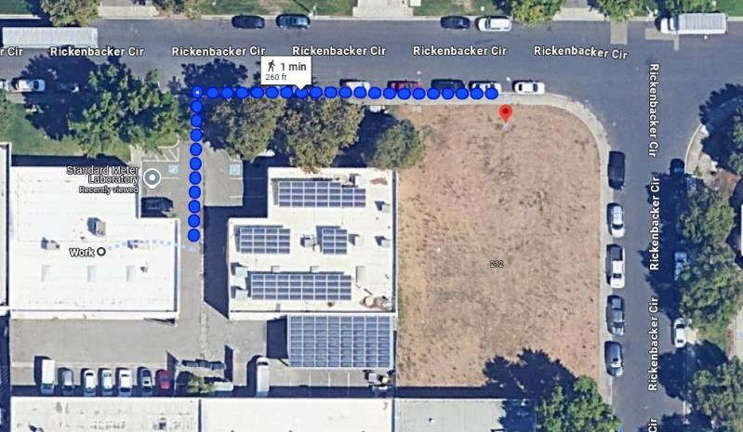

INTRODUCTION

Purpose: This guide outlines the procedures to be followed in the event of an emergency at

this location. All personnel should familiarize themselves with these procedures to ensure their safety and the safety of others.
Responsibilities:

- Management: Responsible for implementing and maintaining the Emergency Action Plan, conducting drills, and ensuring all employees are trained.
- Employees: Responsible for knowing and following the procedures outlined in this guide, participating in drills, and reporting any unsafe conditions.

Designated Emergency Personnel: BLS-AED Certified Personnel

Marcos Estrella

James Bradley

Quiana Cosby

When to Evacuate:

- Fire alarm sounds.
- Verbal order from management or emergency personnel.
- Any situation were staying inside the building poses an immediate threat to life or safety.

Evacuation Routes:

- Primary and secondary evacuation routes are posted throughout the building.
Familiarize yourself with the routes closest to your work area.

Procedures:

- Remain Calm: Do not panic.
- Assist Others: If safe to do so, assist individuals with disabilities or those needing help.
- Leave Quickly: Proceed to the nearest exit in an orderly manner.
- Do Not Use Elevators: Use stairwells only.
- Close Doors: Close doors behind you to help slow the spread of fire or smoke.
- Proceed to Meeting Place: Go directly to the designated meeting place (Dumpster, 236 Rickenbacker Circle, Livermore, CA 94551).
- Accountability: Report to your designated supervisor or emergency personnel for a headcount.
- Do Not Re-enter: Do not re-enter the building until authorized by emergency services.

Emergency Contacts:

- Emergency Services: 9-11
- Livermore Police Department (Non-Emergency): (925) 371-4900
- Livermore Fire Department (Non-Emergency): (925) 960-4000

Nearest Emergency Room:
Stanford Health Care Tri-Valley Emergency Department 5555 W Las Positas Blvd, Pleasanton, CA 94588
(925) 416-3418
- Poison Control: 1-800-222-1222
- Building Management: Marcos Estrella (209)-453-4200

Policy: This site respects the right to peaceful assembly and protest. However, the safety and security of employees and property are paramount.

Procedures:

- Do Not Engage: Avoid confrontation or interaction with protestors.
- Report to Management: Notify management of any protest activity.
- Secure the Area: If directed, secure entrances, exits, and windows.
- Follow Instructions: Follow any instructions given by management or law enforcement.
- Business Continuity: Management will determine if business operations need to be modified or suspended.

Definition: A major accident is any incident resulting in serious injury, significant property damage, or disruption of operations.

Procedures:

- Ensure Safety: Assess the scene for immediate dangers and ensure your safety.
- Provide Assistance: If safe to do so, provide first aid to injured individuals.
- Call 911: Immediately report the accident to emergency services.
- Notify Management: Inform management or designated emergency personnel.
- Secure the Area: Prevent access to the accident site to preserve evidence and prevent further injuries.
- Document: If possible, take photos or notes of the accident scene (after ensuring safety).
- Cooperate: Fully cooperate with investigators and emergency personnel.

Potential Hazards: Cleaning chemicals, fuels, electrical wiring/equipment in High Voltage Room.

Procedures:

- Evacuate: If a spill or leak occurs, clear/ mark the area immediately with caution cone.
- Notify Management: Inform management or designated emergency personnel.
- Do Not Attempt Cleanup: Unless specifically trained and equipped to do so, do not attempt to clean up chemicals/hazards without proper PPE & or Training.
- Isolate: If possible, isolate the area to prevent the spread of contamination.
- Follow Instructions: Follow any instructions given by emergency personnel or HAZMAT teams.
- Decontamination: If you come into contact with the hazardous material, follow decontamination procedures as directed.

Procedures:

- Assess the Situation: Determine the nature of the emergency and the victim’s condition.
- Call 911: If the situation is life-threatening or requires immediate medical attention, call 911.
- Provide First Aid: If trained, provide first aid until emergency personnel arrive.
- Notify Management: Inform management or designated first aid responders.
- Comfort and Reassure: Stay with the victim and provide comfort and reassurance.
- AED: If the victim is unconscious and not breathing, use an Automated External Defibrillator (AED) if one is available and you are trained to use it.
- Clear the Area: Ensure the area around the victim is clear for emergency personnel.

Procedures:

- Remain Calm: Do not panic or resist.
- Cooperate: Follow the robber’s instructions. Your safety is the priority.
- Observe: Try to remember details about the robber’s appearance (height, weight, clothing, etc.).
- Do Not Chase: Do not attempt to follow or apprehend the robber.
- Call 911: As soon as it is safe to do so, call 911 and report the robbery.
- Notify Management: Inform management or security.
- Secure the Area: Secure the area and preserve any evidence.
- Witness Statements: Provide a detailed statement to law enforcement.

If you receive a bomb threat:
- Stay Calm: Do not panic.
- Keep the Caller on the Line: Try to keep the caller on the line as long as possible.
- Ask Questions (Use the checklist below):
- When is the bomb going to explode?
- Where is the bomb right now?
- What does it look like?
- What kind of bomb is it?
- What will cause it to explode?
- Did you place the bomb?
- Why?
- What is your address?
- What is your name?
- Note Caller’s Voice: Pay attention to the caller’s voice (gender, accent, tone, etc.).
- Listen for Background Noises: Note any background noises that might help identify the caller’s location.
- Write Down the Exact Wording of the Threat:
- Call 911 Immediately After Hanging Up: Report the threat to emergency services.
- Notify Management: Inform management or security.

Characteristics of a Suspicious Package:

- Unexpected or unknown sender.
- Excessive postage.
- Strange odor.
- Oily stains or discoloration.
- Protruding wires or tinfoil.
- Lopsided or uneven shape.
- Strange sounds (ticking, etc.).

Procedures:

- Do Not Touch: Do not touch or move the package.
- Isolate the Area: Clear the area around the package.
- Call 911: Report the suspicious package to emergency services.
- Notify Management: Inform management or security.
- Follow Instructions: Follow any instructions given by emergency personnel.

In Case of Fire:

- R.A.C.E.
- Rescue: If safe to do so, rescue anyone in immediate danger.
- Alarm: Activate the nearest fire alarm pull station.
- Confine: Close doors and windows to confine the fire.
- Extinguish/Evacuate: If the fire is small and you are trained, use a fire extinguisher.
Otherwise, evacuate.

- Call 911: Report the fire to emergency services.
- Evacuate: Follow the evacuation procedures outlined on Page 2.
- Do Not Use Elevators: Use stairwells only.
- If Trapped: Stay low to the ground, cover your mouth with a wet cloth if possible, and signal for help from a window.

Fire Extinguisher Use (P.A.S.S.):

- Pull the pin.
- Aim at the base of the fire.
- Squeeze the handle.
- Sweep from side to side.

Earthquake:

- Drop, Cover, and Hold On: Drop to the ground, take cover under a sturdy object (desk or table), and hold on until the shaking stops.
- Stay Indoors: Do not run outside during the shaking.
- After Shaking Stops: Evacuate the building if necessary, following evacuation procedures.
- Be Aware of Aftershocks: Aftershocks can occur minutes, hours, or even days after the main earthquake.

Flood:

- Monitor Weather Reports: Stay informed about weather conditions and flood warnings.
- Evacuate if Necessary: If authorities issue an evacuation order, follow it immediately.
- Do Not Drive Through Flooded Areas: Turn around, don’t drown.
- After Flooding: Be cautious of debris, contaminated water, and damaged structures.

Tornado/Severe Thunderstorm:

- Seek Shelter Immediately: Go to a designated storm shelter or an interior room on the lowest level of the building, away from windows.
- Stay Informed: Monitor weather reports and listen for sirens or warnings.
- After the Storm: Be cautious of downed power lines, debris, and damaged structures.

Wildfire:

- Monitor for Warnings: Be aware of any fire warnings issued by authorities.
- Prepare to Evacuate: Gather essential items and necessary medications in case an evacuation is ordered.
- Evacuate Immediately if Ordered: Follow designated routes and do not delay.
- Stay Informed: Keep updated on the fire’s status through official channels.

Extreme Heat:

- Stay Hydrated: Drink plenty of water throughout the day.
- Take Breaks: Take frequent breaks in cool, shaded areas.
- Wear Light Clothing: Wear loose-fitting, light-colored clothing.
- Monitor for Heat-Related Illness: Be aware of the signs of heat exhaustion and heat stroke.

Extreme Cold/Snow/Ice:

- Dress in Layers: Wear multiple layers of warm clothing.
- Limit Outdoor Exposure: Minimize time spent outdoors.
- Watch for Ice: Be cautious of slippery surfaces.
- Monitor Weather Reports: Stay informed about weather conditions and travel advisories.
- Building Closure: Management will determine if the building needs to be closed due to severe weather.

Heavy Rain/Wind:

- Secure Outdoor Objects: Secure any loose objects that could be blown around by the wind.
- Avoid Driving in Heavy Rain: If possible, postpone travel until conditions improve.
- Be Aware of Potential Hazards: Watch for falling debris, downed power lines, and flooded areas.

