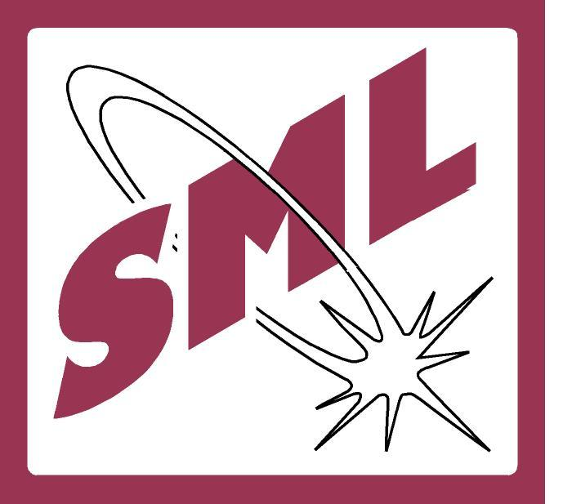 NON - CONFORMANCE REPORT (NCR)
Audit Area : Auditee :
Auditor (s) : NCR Repeat : Y N
Non-Conformity Details | Attribution
Observation: | Doc. Ref no:
Observation: | Page no: of
Observation: | ISO 17025: 2017  ISO 9001: 2015
Explanation: | Main Clause no:
Explanation: | Sub-Clause no:
Auditor (s) Signature & Date: Auditee representative acknowledgement:
Root Cause Analysis (how/why did this happen?) :
Correction (Fix now) with Completion date:

Corrective Action (to prevent recurrence) with completion dates:

EDC: |  | ADC:
Auditee Signature: |  |  | Date:
Follow-up audit Observation:
NCR Closed out by “Auditor” on (date): |  | Auditor Name:
*EDC – Expected date of completion. ADC – Actual date of completion.

Sl. No.: of
Date :
Time :
Shift :

